**Name : Vishal Thakor**

**Date : 17-06-2025…**

**Add File Associations via MSI**

1. **What is msi :-** An MSI file (Microsoft Installer file) is a special type of installation package used on Windows to install, update, or uninstall software. It uses the Windows Installer service (msiexec.exe) to manage the process.

Msi file contains Files to be installed,Installation instructions,Registrychanges,

Shortcuts,Custom actions and Uninstall information

1. **What is a file associations :** A file association links a file extension (like .txt, .jpg, or .mp4) with a default program that can open it.

For example:

**.txt →** opens with Notepad

**.jpg →** opens with Photos

**.mp4 →** opens with Movies & TV (or VLC, if installed)

1. **Goal :** Main goal of this project is a file asociations to a application using msi file.

I am going to use firefox msi file for file association with file extentions like .vishu,.cpp,.ram.

You can download firefox msi from [here](https://www.exemsi.com/downloads/packages/Firefox/Firefox%20Setup%2014.0.1.msi).

1. **Tool used :** there are many ways and tools available in he markey for file association ,

Like : Advance installer GUI,Orca Tool, instead.but o have used orca for msi file association.

**Orca Tool :** Orca is a free Windows Installer package editor from Microsoft. It lets you directly view and edit the internal database tables of .msi including setting file associations, modifying components, registry entries, shortcuts, and more.

You can download orca sdk tool from [link](https://go.microsoft.com/fwlink/?linkid=2320455).

After download you will see a **winsdksetup.exe** file.



1. **Project Requirements :**

**To complete this project, the following tools and files are needed:**

* + Windows Operating System (Windows 10 or 11)
  + Windows SDK (to install the Orca tool)
  + Orca Tool (used to edit the MSI file)
  + Firefox MSI File (e.g., Firefox.msi)
  + Basic knowledge of how MSI files work
  + Notepad (to create a .vishu,.ram test file)
  + Files with custom extentions. (like .ram .vishu .cpp)
  + Admin rights (to install SDK and run MSI)

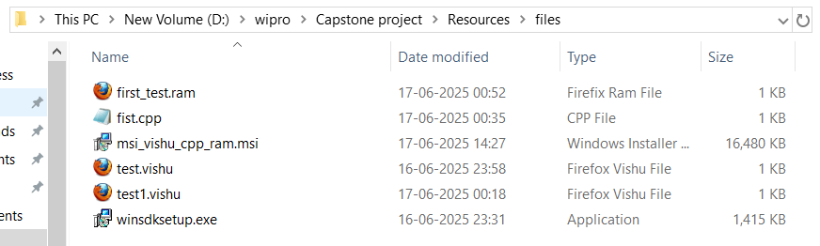

1. **Steps to install Orca :** double click or execute the winsdksetup.exe file ,which is downloaded recently.

Follow the installation wizard,your orca sdk will be installed at your specified location in installation wizard.

My orca sdk is downloaded at path : C:\Program Files (x86)\Windows Kits

1. **Steps to associate file with msi :** first open Orca tool.

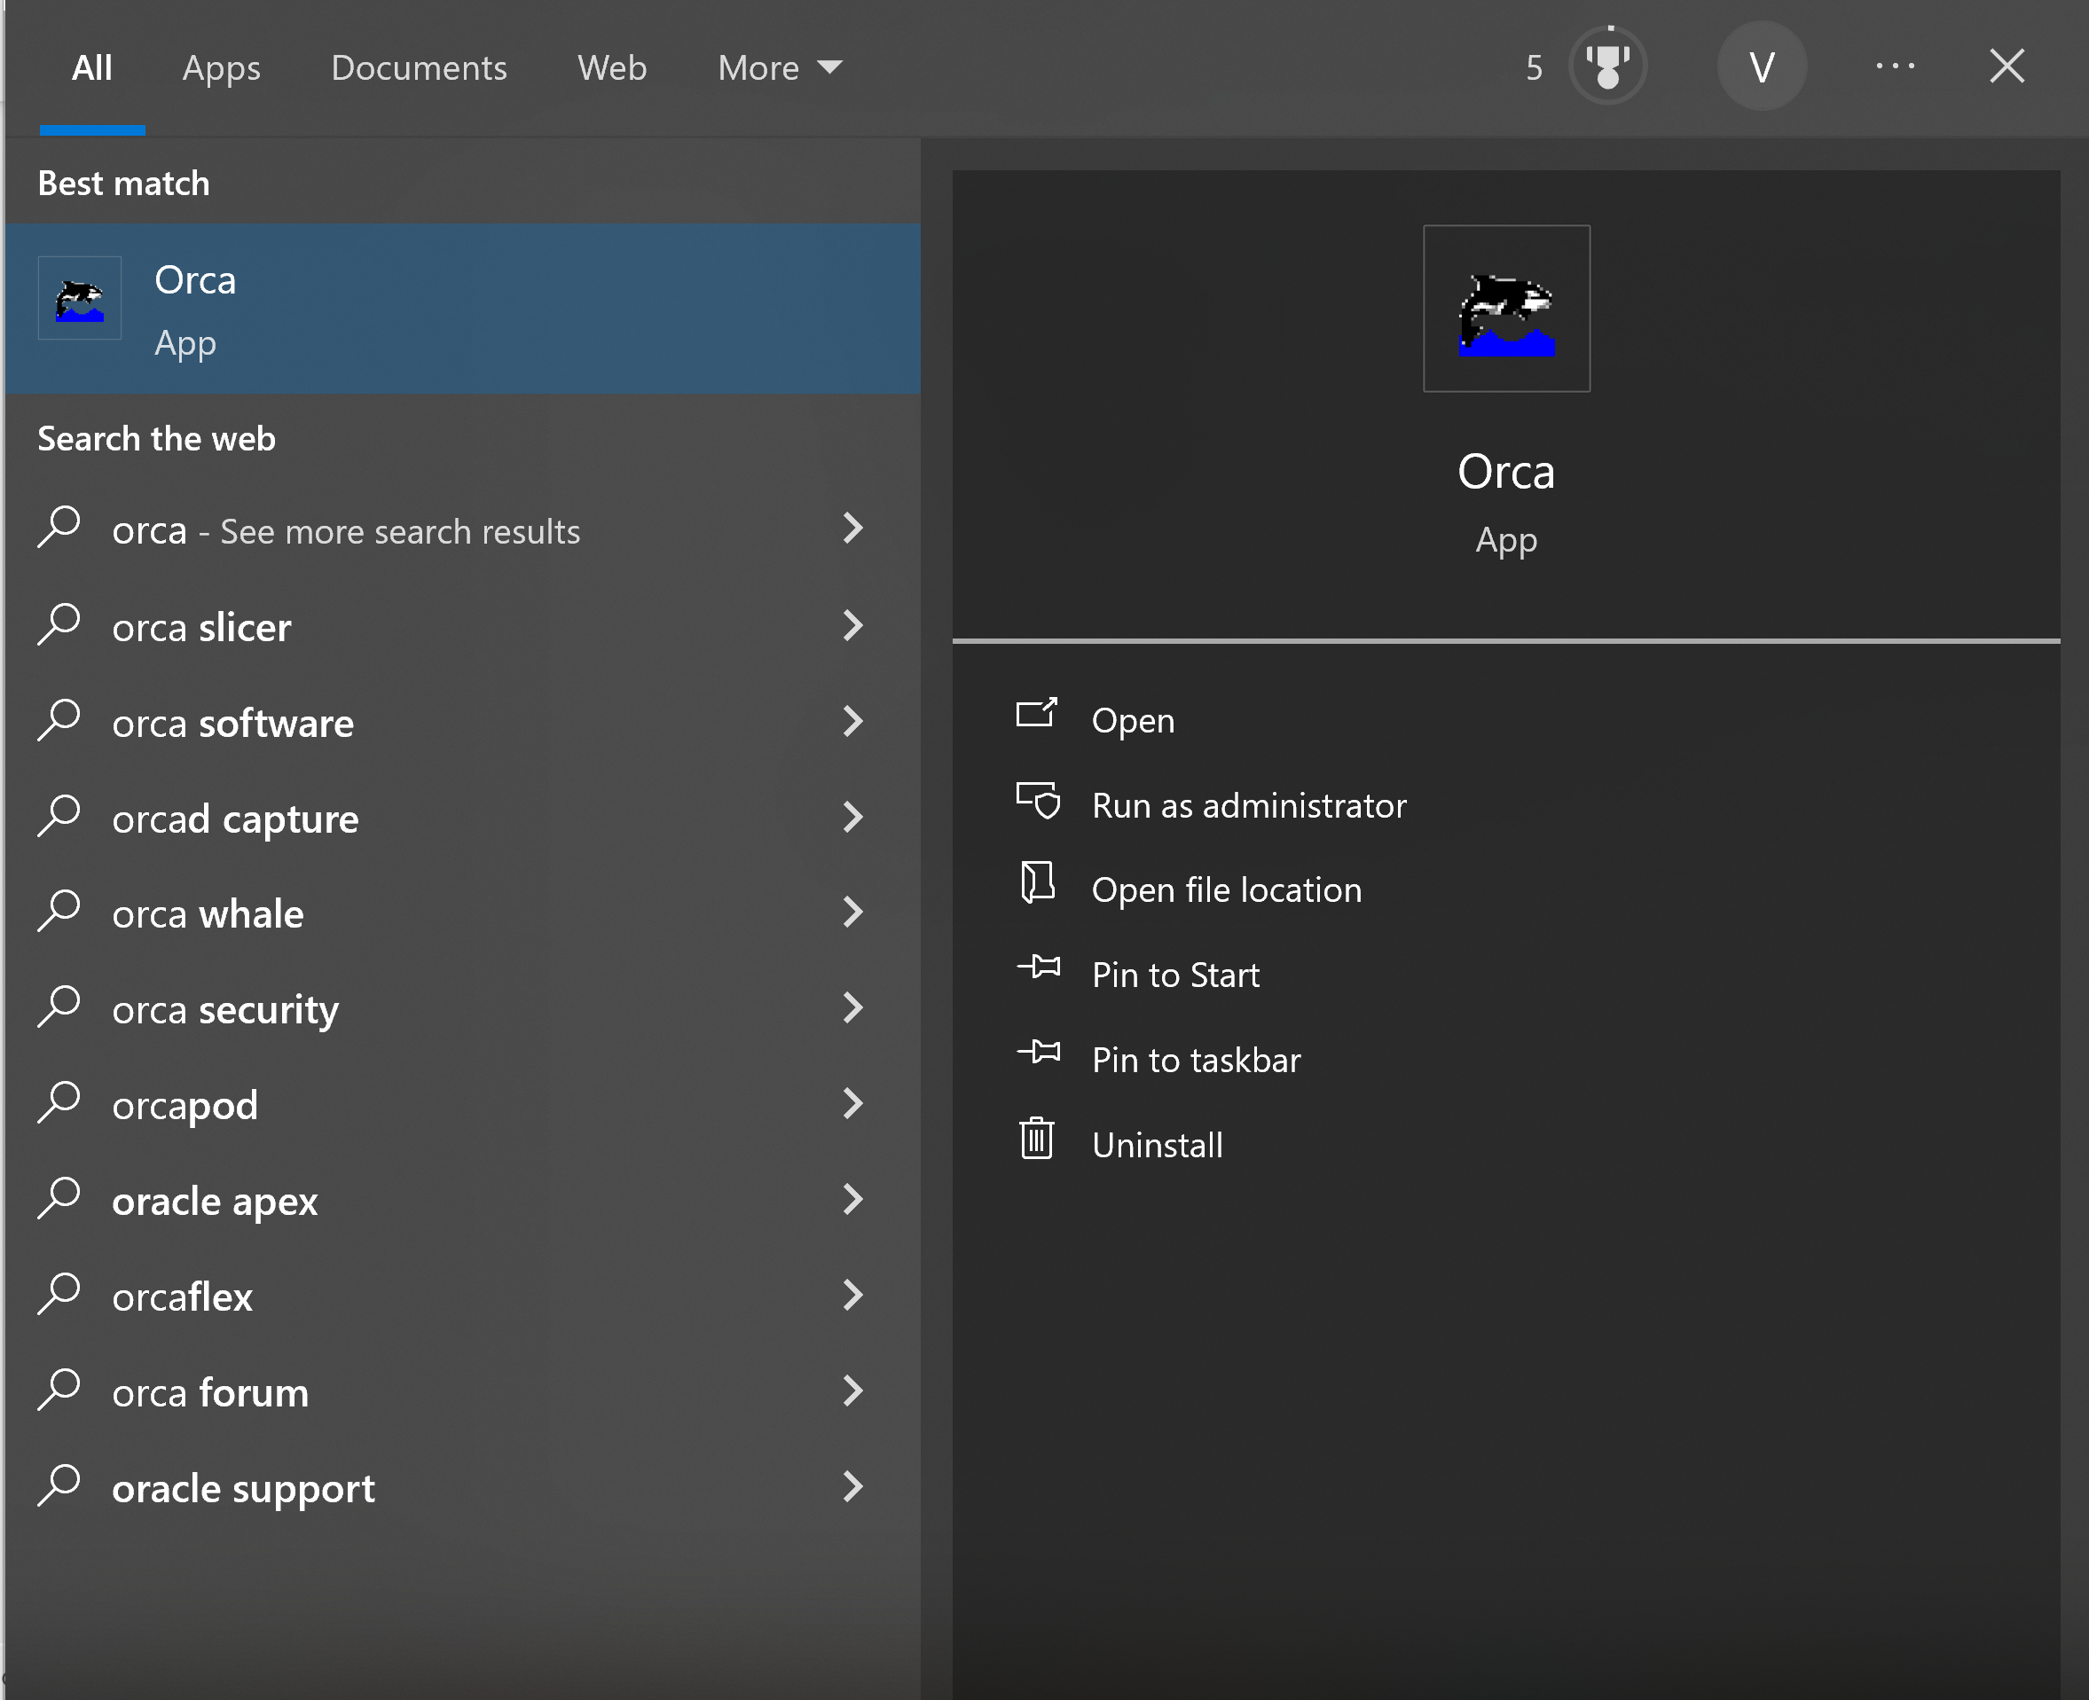

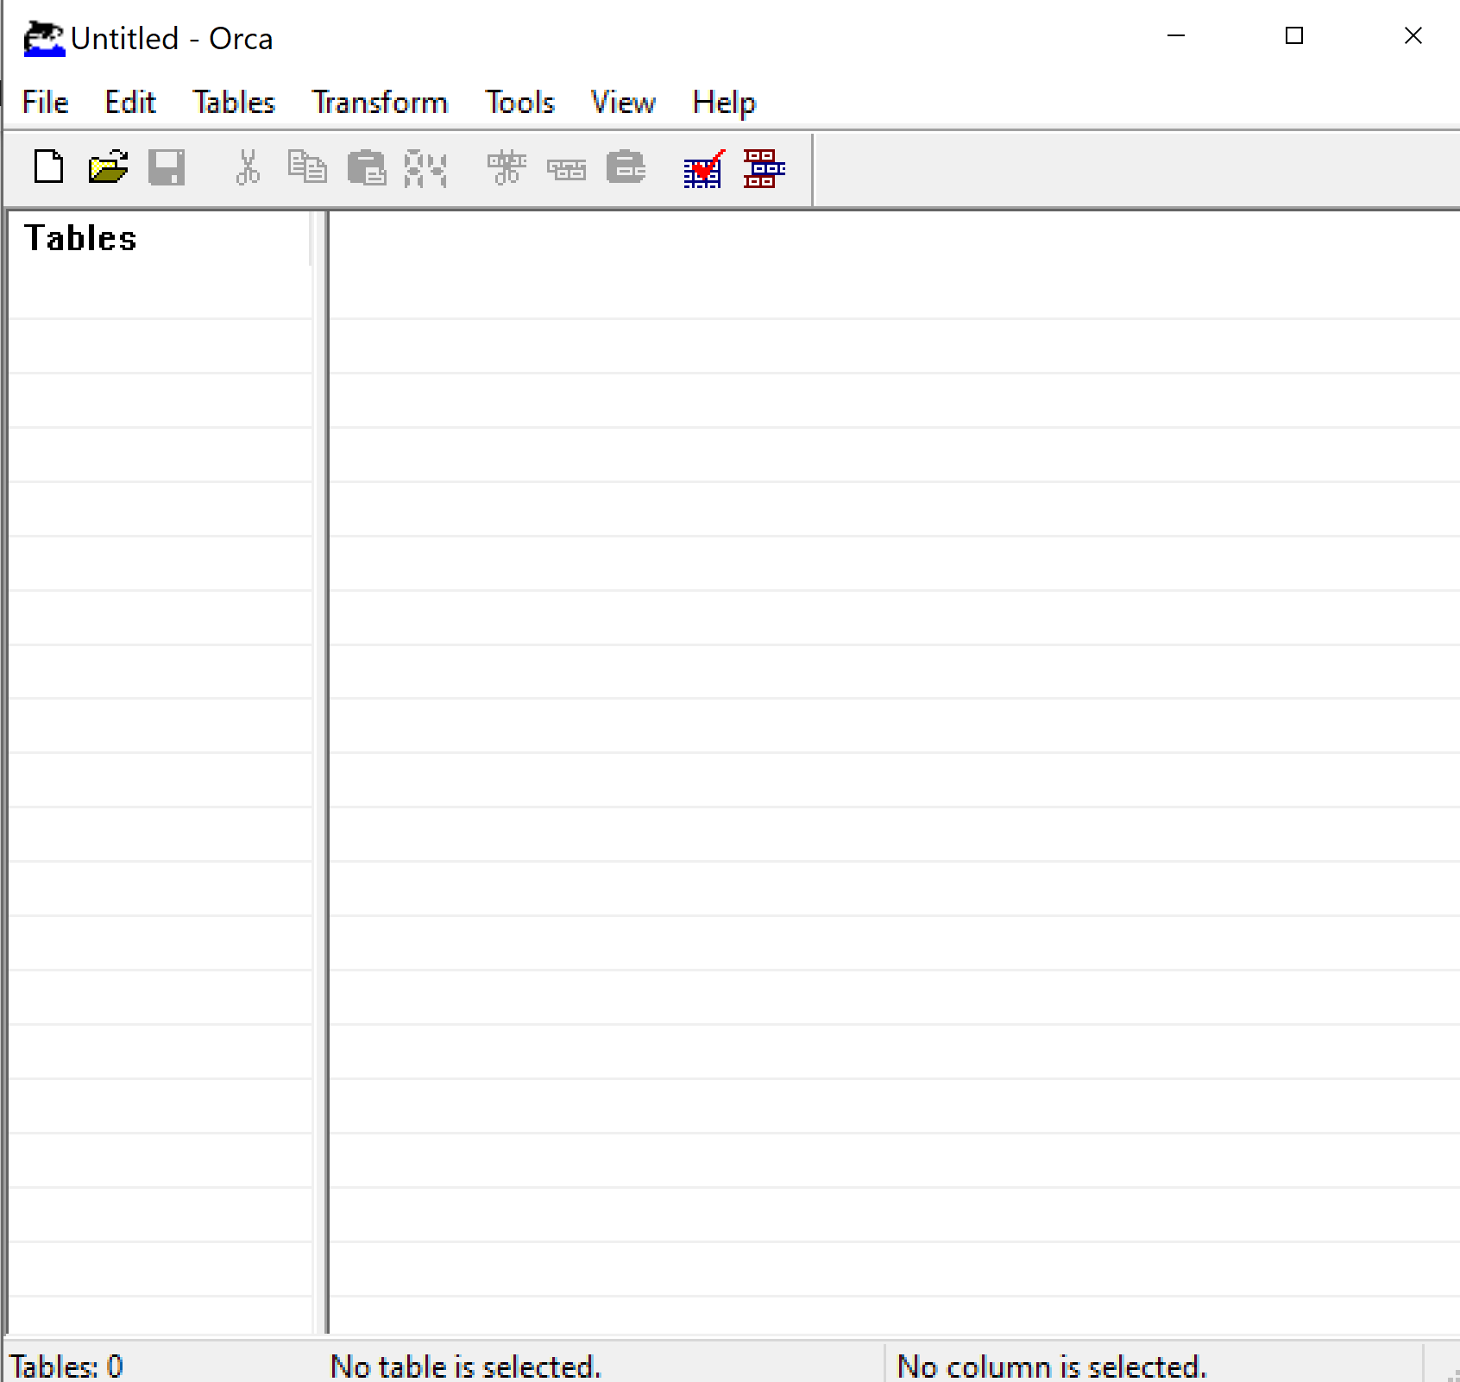

Open the msi file with which, you want to asocoate a custom files.

I am using firefox msi file.

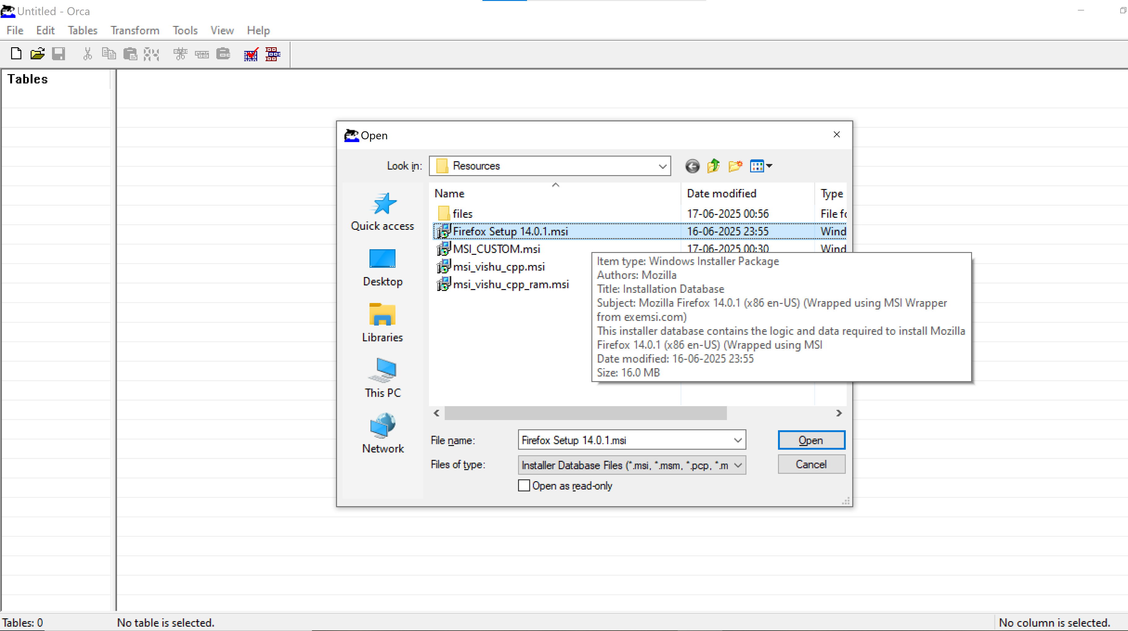

After opening msi file succesfuly, navigate to tables pane in left side and find for registry table and open it.

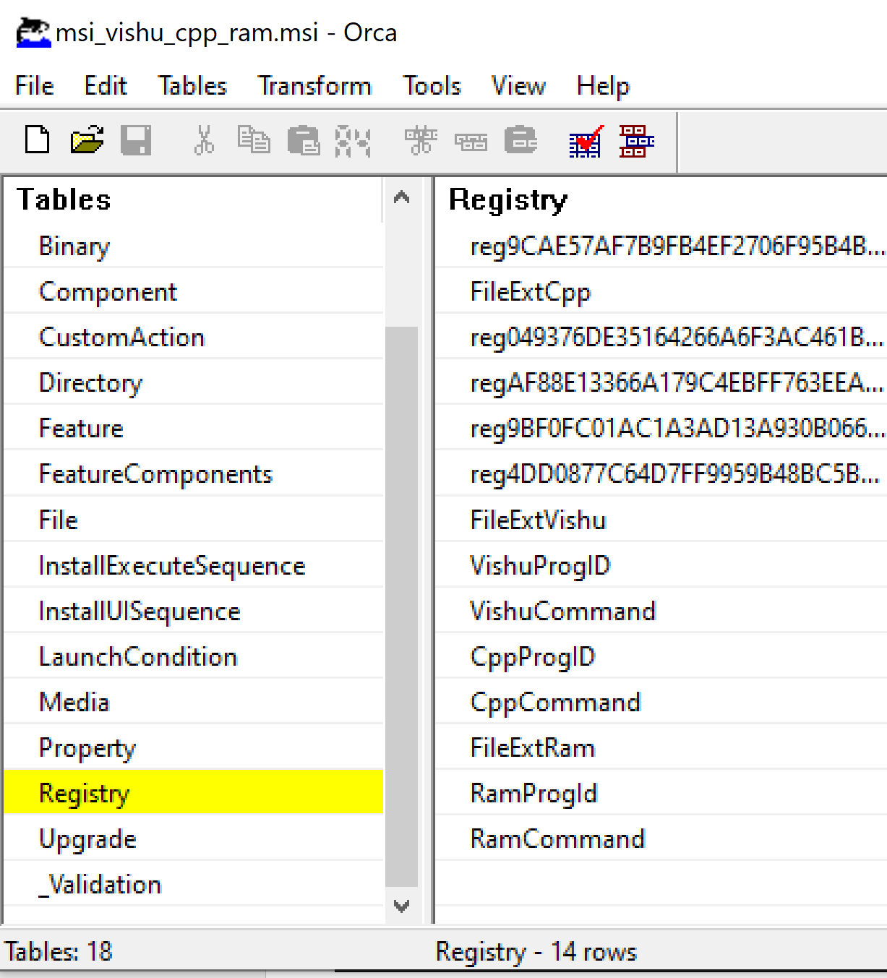

If there is no registry able then click on table meuu at tool bar and navigate to add Table and

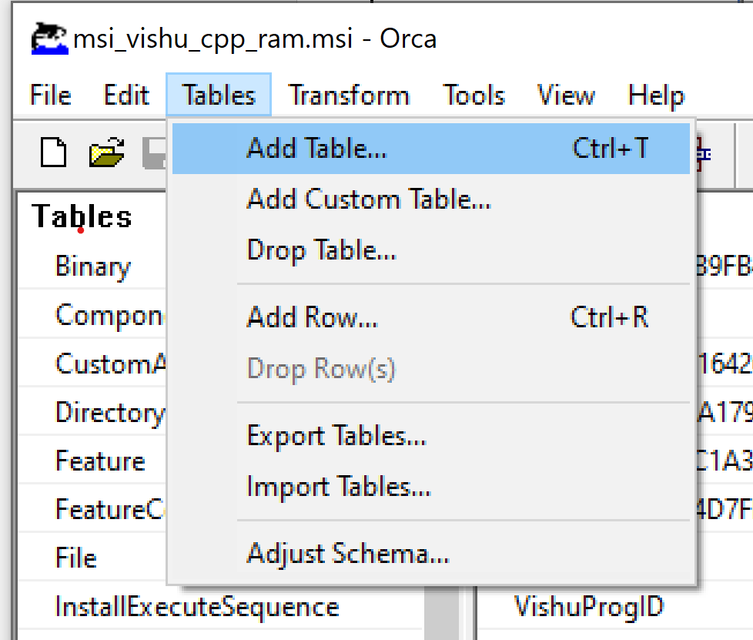Check registry and click ok.

After opening registry table right click and select add row.

For one extention you have to add three registry values.

(File extention,Prog id and Command)

Add registry keys as below.

1. **Registries for .vishu extention:**

|  |  |  |  |  |
| --- | --- | --- | --- | --- |
| **Registry** | **Root** | **Key** | **Value** | **Component** |
| FileExtVishu | 0 | .vishu | FirefoxHTML.vishu | bz.ProductComponent |
| VishuProgID | 0 | FirefoxHTML.vishu | Firefox Vishu File | bz.ProductComponent |
| VishuCommand | 0 | FirefoxHTML.vishu\shell\open\command | "C:\Program Files (x86)\Mozilla Firefox\firefox.exe" "%1" | bz.ProductComponent |

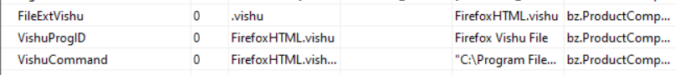

1. **Registries for .cpp extention**

|  |  |  |  |  |
| --- | --- | --- | --- | --- |
| **Registry** | **Root** | **Key** | **Value** | **Component** |
| CppProgID | 0 | FirefoxHTML.cpp | Firefox CPP File | bz.ProductComponent |
| CppCommand | 0 | FirefoxHTML.cpp\shell\open\command | "C:\Program Files (x86)\Mozilla Firefox\firefox.exe" "%1" | bz.ProductComponent |





1. **Registries for .ram extention**

|  |  |  |  |  |
| --- | --- | --- | --- | --- |
| **Registry** | **Root** | **Key** | **Value** | **Component** |
| FileExtRam | 0 | .ram | FirefoxHTML.ram | bz.ProductComponent |
| RamProgId | 0 | FirefoxHTML.ram | Firefix Ram File | bz.ProductComponent |
| RamCommand | 0 | FirefoxHTML.ram\shell\open\command | "C:\Program Files (x86)\Mozilla Firefox\firefox.exe" "%1" | bz.ProductComponent |

**All Registry vaues are :**

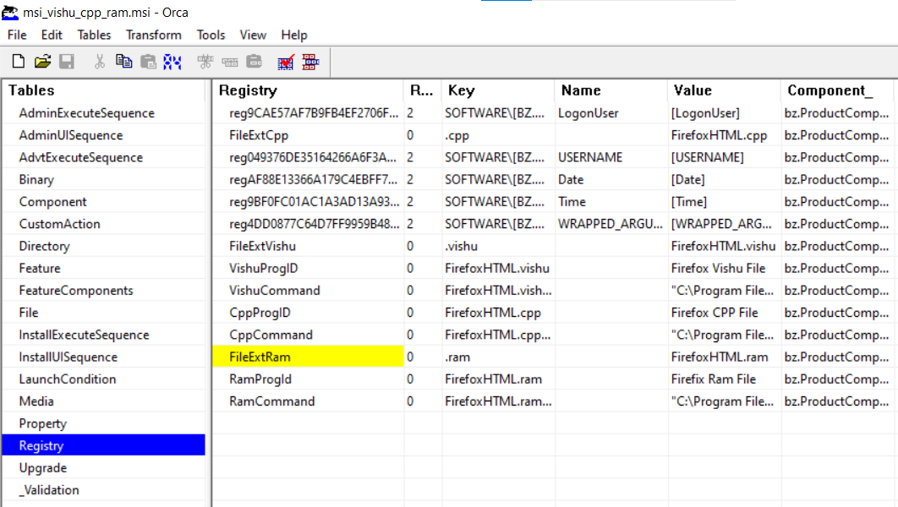

**Registry :** it is a unique identifier (primary key) for this registry entry.

**Root:** Specifies the root key in the Windows Registry. 0 for default.

**Value :** The subkey (path) under the root where the value will be written.

**Component :** References a component that controls the installation/uninstallation of this registry key/value.

1. Got to file mu and savefile as save as file and give a custom ane to file.

Eg. **msi_vishu_cpp_ram.msi**

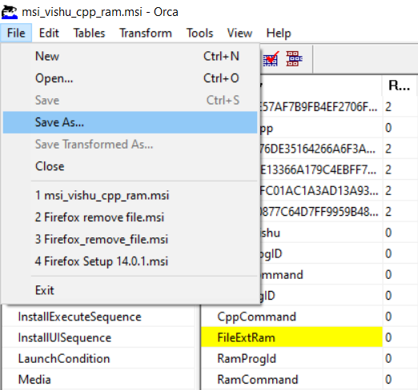

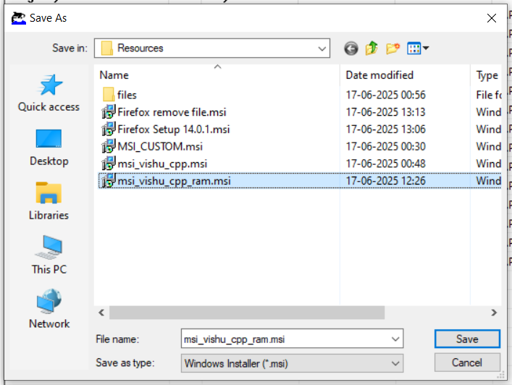

My msi file is stored at location : “**D:\wipro\Capstoneproject\Resources\msi_vishu_cpp_ram.msi”**

1. **Run the custom msi file :**

Go to msi file location and run firefox msi setup file.

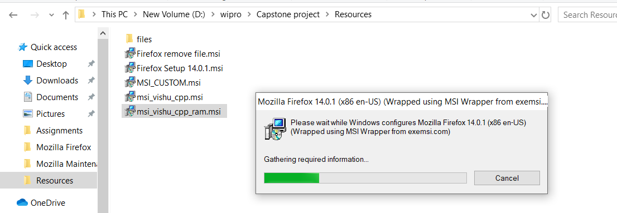

Installation wizard will be shown.complete the installation using follow the wizard.

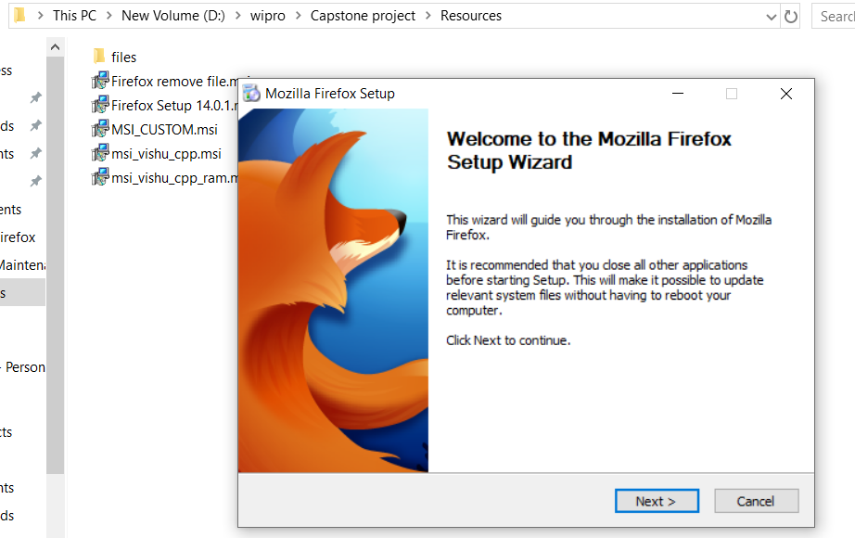

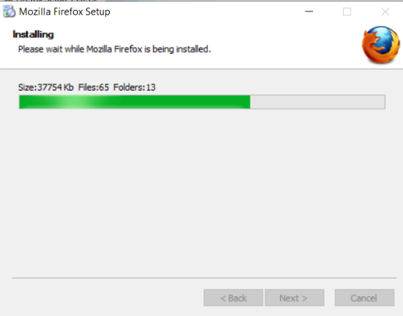

1. **Create a text file:** open notepad and create a text file with custom extention and save it. My file is stored at : D:\wipro\Capstone project\Resources\files\test.vishu

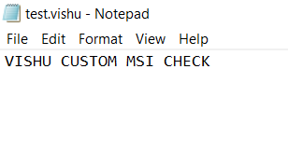

1. Goto that custom text file and open it.

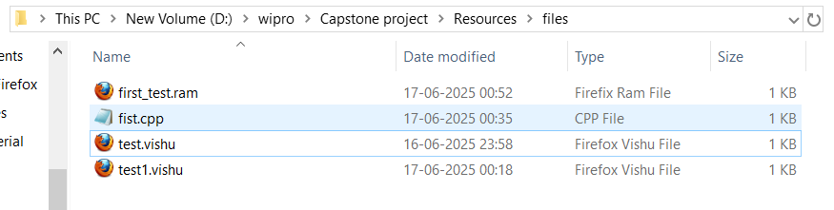

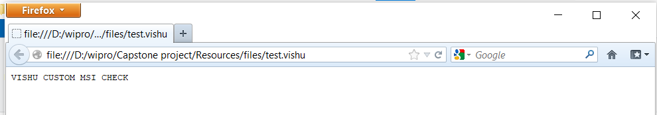 **The file will be automatically opened in firefox browser in rea-only mode.**